Activity 2: Angular Installation

Ryan Coon

CST-391

Professor Bobby Estey

July 14, 2023

**Screenshots:**

Here we can see the installation was successful with the version of each module shown.

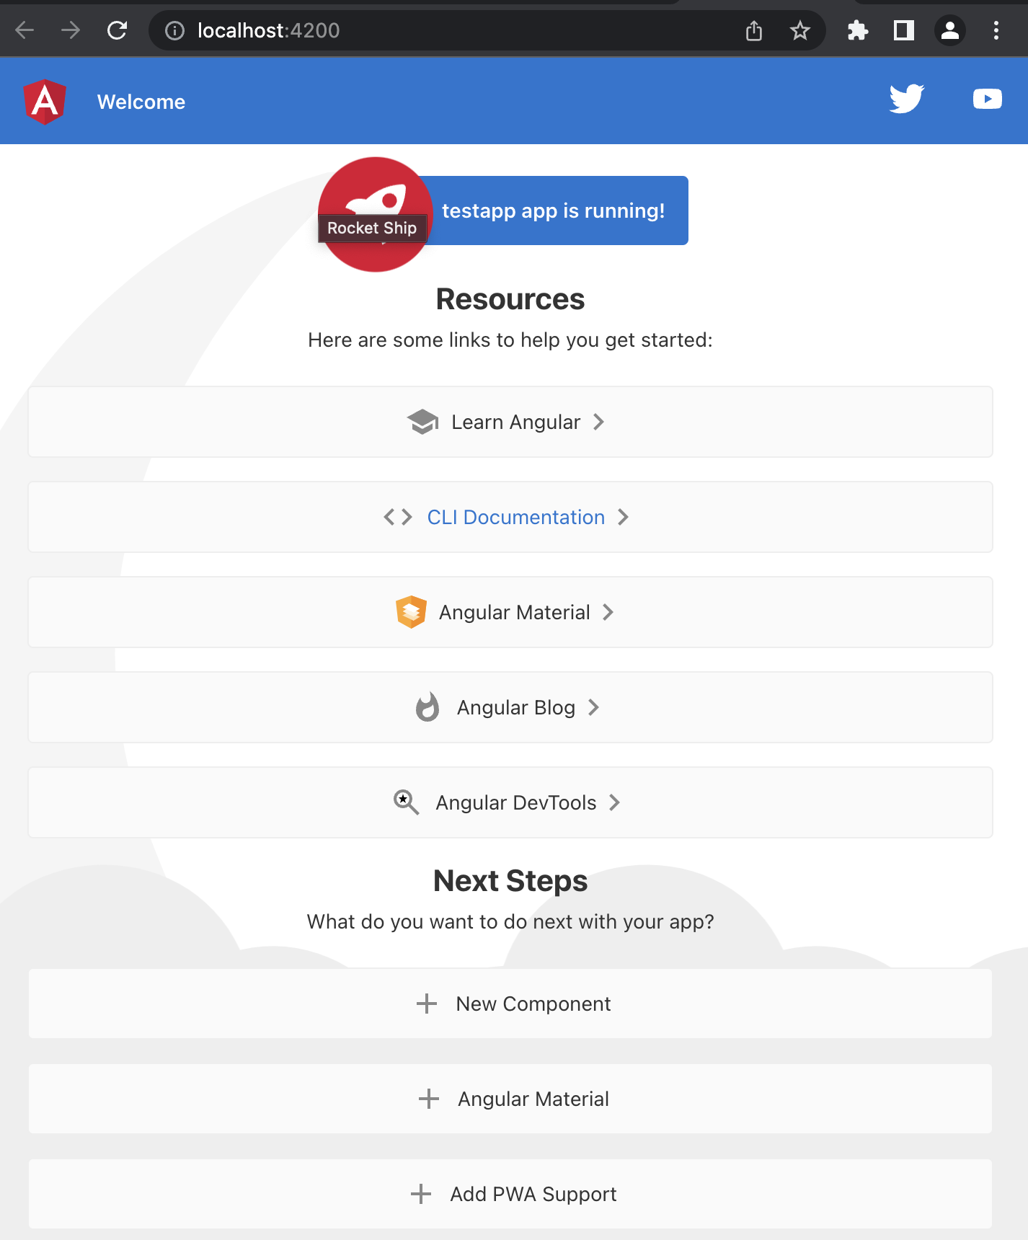

Here we can see the testapp we created through the terminal after I started the server.

Here is the testapp with the edited title to show how to change the title elelement.

Here we added an h3 tag into the html linked to the “message” component. We then created the message component within the app.component.ts file with our name as the content.

**Research:**

Inspect the default test project structure created in the Activity. Describe the purpose for each of the folders of the following in the project structure: node_modules, src, src/app, src/assets, and src/environments. Also, describe the purpose for each of the following files in the project: angular.json, package.json, and tsconfig.json.

**Project Structure Folders:**

* Node_modules – These provide npm packages throughout the entire workspace. This then allows the dependencies to be visible throughout all projects.
* Src – This is where source files at the root level of the application go.
* Src/app – This folder contains logic and data for the project. Templates, styles, and Angular components are found here.
* Src/assets – This folder contains assets as stated like images, videos, scripts, and JSON files.
* Src/environments – The projects base configuration files are found here, which provides configuration for production in the default environment.

**Project Structure Files:**

* Angular.json – CLI config defaults for all projects in the workspace, including config options for the build, serve, and test tools in which the CLI uses.
* Package.json – This configures the npm package dependencies that are available to all projects within the workspace.
* Tsconfig.json – This is the TypeScript configuration for all of the projects within the workspace. All configuration files inherit from this file.

Inspect the page source for the default page displayed when running the test project. Explain how the resultant page was generated by Angular by providing a brief overview and purpose for each of the following files: main.ts, app.component.css, app.component.html, app.component.ts, and app.module.ts.

* Main.ts – This is the main entry point for the application. This compiles the application and “bootstraps” the application’s rood module to run in the web browser.
* App.component.css – This defines the base CSS stylesheet for the root AooComponent.
* App.component.html – This defines the HTML template associated with the root AppComponent.
* App.component.ts – This defines the logic for the applications root component.
* App.module.ts – This defines the root module that then tells Angular how to assemble the application.